**MGMT 2050 - ASSIGNMENT 3B – Winter 2018**

During Session 10 we used a special class list to generate the master file of students with their marks of a specific exam. Since then, the professor of that class has finished the process of creating the master file of the marks and saved the new file as “Assignment 3B - Data file W2018.xls”

Now, the professor needs to post the marks, but his Moodle platform is no longer available and the only thing that he can do is to post the Excel file as is in the CMD system.

Due to privacy elements that the professor must maintain, you should build a solution that will allow the professor to post the Excel file, and allow each student to insert their student ID number to a cell (provide guided instructions for the user in the sheet) and as a response the student will get his/her name and his/her marks in other cells. It can look something like this:

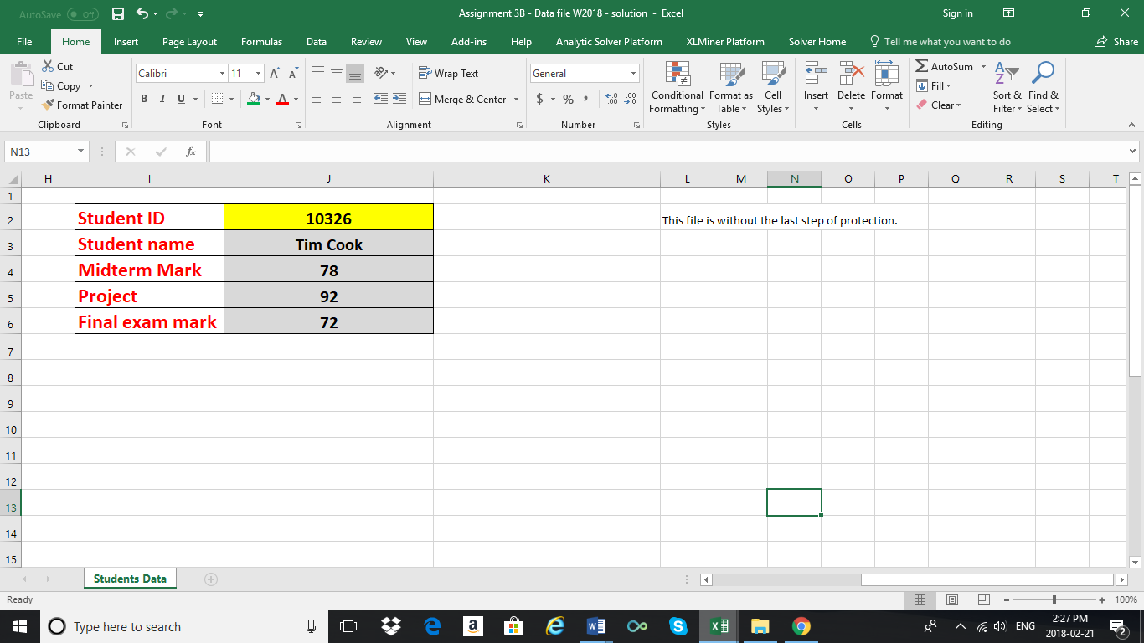

The student should be able to enter their ID number in the yellow cell, and the rest of the information will appear.

Requirements:

1. Students should ONLY have access to records by entering a student number.
2. Students should not be able to see the raw data.
3. You should solve this using only formulas, functions and tools which were introduced in class.

For full credit, you must document each step of preparing your solution with Print Screens and add them to your Word answer file and explain which formulas/functions/tools you have used. Your Word document should include instructions of how to use your solution to view the marks. Upload both the Word document and your Excel file to Moodle.

Hint: Use the number 1234 as your file’s password.

**Steps to Producing a Look Up; Student Results**

Step 1: Produce a table on a separate sheet where students can insert their student numbers



Step 2: Use VLOOKUP using column “Student ID” as the look up value in order to produce numbers for “Student Name”, “Midterm Mark”, “Project Mark”, and “Final Exam Mark”. These values will be found on the previous sheet. Note, the formulas are the same except for the column look up, which is changed to bring back the corresponding term; i.e. either student name or midterm mark or project mark or final exam mark.

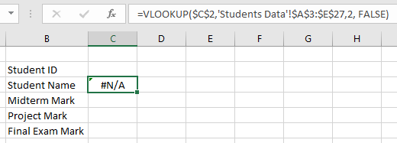

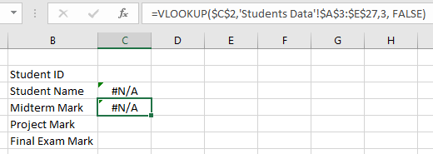

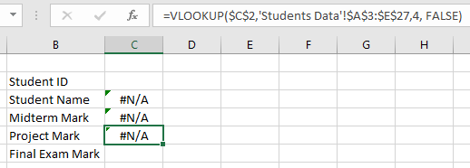

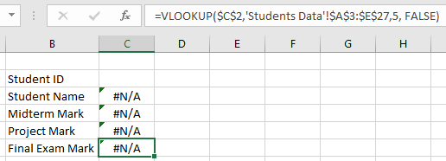

Step 3: Test sheet

input=12584; Stephen Harper

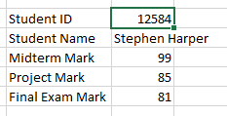

input=85741; Angela Merkel

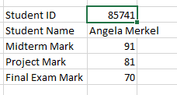

input=99999; random number

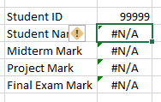

We have determined that the look up works effectively, and can now proceed to make the sheets look more user friendly and apply passwords to prevent the access of raw data

Step 4: User Friendly Changes

We made the sheet more user friendly by highlighting where the student number must be put.

